GSM-BASED VEHICLE THEFT CONTROL SYSTEM
A “Technical Seminar” Report submitted to
JNTU Hyderabad in partial fulfillment
of the requirements for the award of the degree
BACHELOR OF TECHNOLOGY
In
COMPUTER SCIENCE AND ENGINEERING
Submitted by

MUKTHALA SUKENDER 22S11A05B9



DEPARTMENT OF COMPUTER SCIENCE & ENGINEERING
MALLA REDDY INSTITUTE OF TECHNOLOGY & SCIENCE
(Approved by AICTE New Delhi and Affiliated to JNTUH)
(Accredited by NBA & NAAC with “A” Grade)
An ISO 9001: 2015 Certified Institution Maisammaguda, Medchal (M), Hyderabad-500100, T.S.
APRIL 2026

.

INDEX

Chapter | Page No.
ABSTRACT  1.INTRODUCTION  2.WORKING PROCEDURE  2.1 System Architecture  2.2 Working Principle  3.IMPLEMENTATION  4.CONCLUSION | iii  1  2  2  2  4  7
ABSTRACT

The increasing rate of vehicle theft has created a strong need for effective and reliable security systems. A GSM-based vehicle theft control system is designed to enhance vehicle security by integrating wireless communication and embedded technology. This system uses a GSM module along with a microcontroller to enable real-time monitoring and control of the vehicle.
In the event of unauthorized access or theft, the system sends an alert message to the owner’s mobile phone via the GSM network. The owner can then remotely control the vehicle by sending commands such as disabling the engine or locking the system, thereby preventing further movement. Some advanced implementations also integrate GPS modules to provide the exact location of the vehicle.The system is cost-effective, easy to install, and highly efficient in providing security. It reduces dependency on traditional alarm systems by offering remote accessibility and immediate response. This solution demonstrates the practical application of wireless communication in improving vehicle safety and theft prevention.

CHAPTER 1 : INTRODUCTION

With the rapid increase in the number of vehicles worldwide, vehicle theft has become a major concern for owners and law enforcement agencies. Traditional security systems such as mechanical locks and alarm systems are no longer sufficient to prevent theft, as they can be easily bypassed by skilled criminals. This has led to the need for more advanced, reliable, and intelligent security solutions.A GSM-based vehicle theft control system is an innovative approach that uses wireless communication technology to enhance vehicle security. The system integrates a microcontroller with a GSM module to enable communication between the vehicle and the owner’s mobile phone. In case of unauthorized access or suspicious activity, the system immediately sends an alert message to the owner via the GSM network.One of the key advantages of this system is its ability to provide remote control functionality. The vehicle owner can send commands through SMS to control various operations such as stopping the engine, locking the ignition system, or activating alarms. This ensures quick response and reduces the chances of vehicle loss.Additionally, the system can be expanded by incorporating GPS technology to track the real-time location of the vehicle. This combination of GSM and GPS enhances the effectiveness of the system by not only alerting the owner but also helping in recovering the stolen vehicle.Overall, the GSM-based vehicle theft control system provides a smart, cost-effective, and efficient solution to improve vehicle security, making it a valuable advancement in modern automotive safety systems.

CHAPTER 2 : WORKING PROCEDURE
2.1 SYSTEM ARCHITECTURE
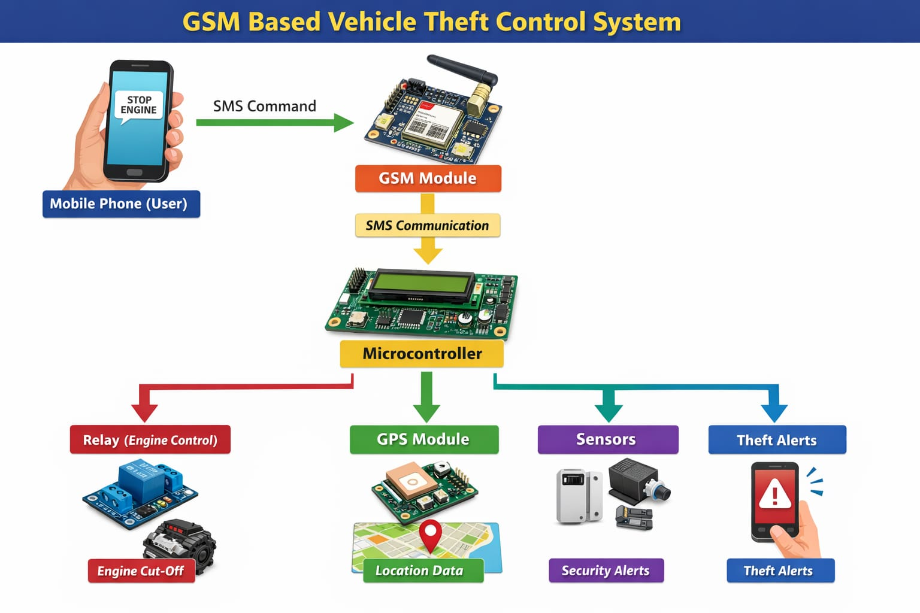
Fig 1: System Architecture
2.2 WORKING PRINCIPLE:
The GSM-based vehicle theft control system operates through communication between the user and the vehicle using SMS via a GSM module. The step-by-step working procedure is explained below:
Step 1: System Initialization
- When the vehicle is powered ON, the microcontroller initializes all components.
- The GSM module connects to the mobile network.
- System enters standby mode waiting for input.
Step 2: Monitoring Vehicle Status
- The system continuously monitors:
  - Ignition status
  - Door sensors (if available)
- If any unauthorized activity is detected, it triggers an alert.

Step 3: Alert Generation
- If theft or unauthorized access occurs:
  - GSM module sends an SMS alert to the owner.
  - Example:message
Step 4: Receiving User Command
- The owner sends an SMS command to the GSM module.
- Common commands include:
  - STOP → Turn OFF engine
  - START → Turn ON engine
  - STATUS → Get vehicle condition
Step 5: Command Processing
- GSM module receives the SMS.
- It forwards the message to the microcontroller via serial communication.
- The microcontroller:
  - Reads the message
  - Verifies authorized number
  - Matches command with predefined instructions
Step 6: Feedback to User
- After executing the command:
  - GSM module sends confirmation SMS
Step 7: Continuous Operation
- The system continues to monitor vehicle status.
- It remains active for further commands or alerts.

CHAPTER 3 : IMPLEMENTATION
The implementation of the GSM-based vehicle theft control system involves hardware setup, software programming, and system integration. This section explains how the system is built and deployed practically.
1. Hardware Implementation
Components Used :
- Microcontroller (Arduino / PIC / 8051)
- GSM Module (SIM800 / SIM900)
- Relay Module
- Power Supply Circuit
- Vehicle Battery (12V)
- Connecting wires & PCB
Hardware Setup Steps :
Step 1: Power Supply Setup
- Vehicle battery (12V) is stepped down to 5V using voltage regulator.
- This powers the microcontroller and GSM module.
Step 2: GSM Module Connection
- GSM module is connected to microcontroller using UART communication:
  - TX → RX
  - RX → TX
- A SIM card is inserted for network communication.
Step 3: Relay Connection
- Relay is connected to a digital output pin of the microcontroller.
- Relay acts as a switch to control vehicle ignition.
Step 4: Ignition System Integration
- Relay is connected in series with the vehicle ignition circuit.
- When relay is OFF → engine stops
- When relay is ON → engine runs
Step 5: Optional GPS Integration
- GPS module can be connected for tracking.
- Sends coordinates via GSM SMS.

2. Software Implementation :
Programming Language :
- Embedded C / Arduino IDE
Key Functional Modules :
1. GSM Initialization
- Configure GSM module using AT commands:
  - AT → Check communication
  - AT+CMGF=1 → Set SMS mode
  - AT+CNMI=2,2,0,0,0 → Auto-receive SMS
2. Message Reading
- Microcontroller reads incoming SMS via serial port.
- Stores message in buffer.
3. Command Processing Logic
- Compare received message with predefined commands:
  - “STOP” → Turn OFF relay
  - “START” → Turn ON relay
4. Security Check
- System verifies authorized mobile number.
- Ignores unknown numbers.
5. Relay Control
- Output pin HIGH/LOW controls relay:
  - HIGH → Engine ON
  - LOW → Engine OFF
6. SMS Feedback
- System sends confirmation SMS using:
  - AT+CMGS command
3. System Integration
- All components are assembled on a PCB or breadboard.
- Connections are secured inside the vehicle dashboard.
- System is tested under real conditions.

4. Algorithm (Simplified)
- Start system
- Initialize GSM module
- Wait for incoming SMS
- Read message
- Check authorized user
- Compare command:
  - If STOP → Turn OFF engine
  - If START → Turn ON engine
- Send confirmation SMS
- Repeat
5. Testing Procedure
- Insert SIM card and power ON system
- Send SMS command from mobile
- Verify:
  - Engine stops/starts correctly
  - SMS response is received
- Simulate theft → check alert message

CHAPTER 4 : CONCLUSION
The GSM-Based Vehicle Theft Control System provides an effective and reliable solution to reduce vehicle theft by enabling remote monitoring and control through mobile communication. By integrating a GSM module with a microcontroller and relay-based ignition control, the system allows the vehicle owner to receive instant alerts and take immediate action, such as stopping the engine via SMS.This system is cost-effective, easy to implement, and highly practical, as it works over long distances using the existing GSM network. The ability to control the vehicle remotely significantly enhances security compared to traditional locking systems.Although the system depends on GSM network availability and may experience slight delays in SMS transmission, it still offers a strong layer of protection against unauthorized vehicle access.In conclusion, the proposed system successfully demonstrates how embedded systems and wireless communication can be combined to create a smart vehicle security solution. With future enhancements such as GPS tracking, mobile applications, and IoT integration, this system can be further improved into a more advanced and intelligent anti-theft system.

